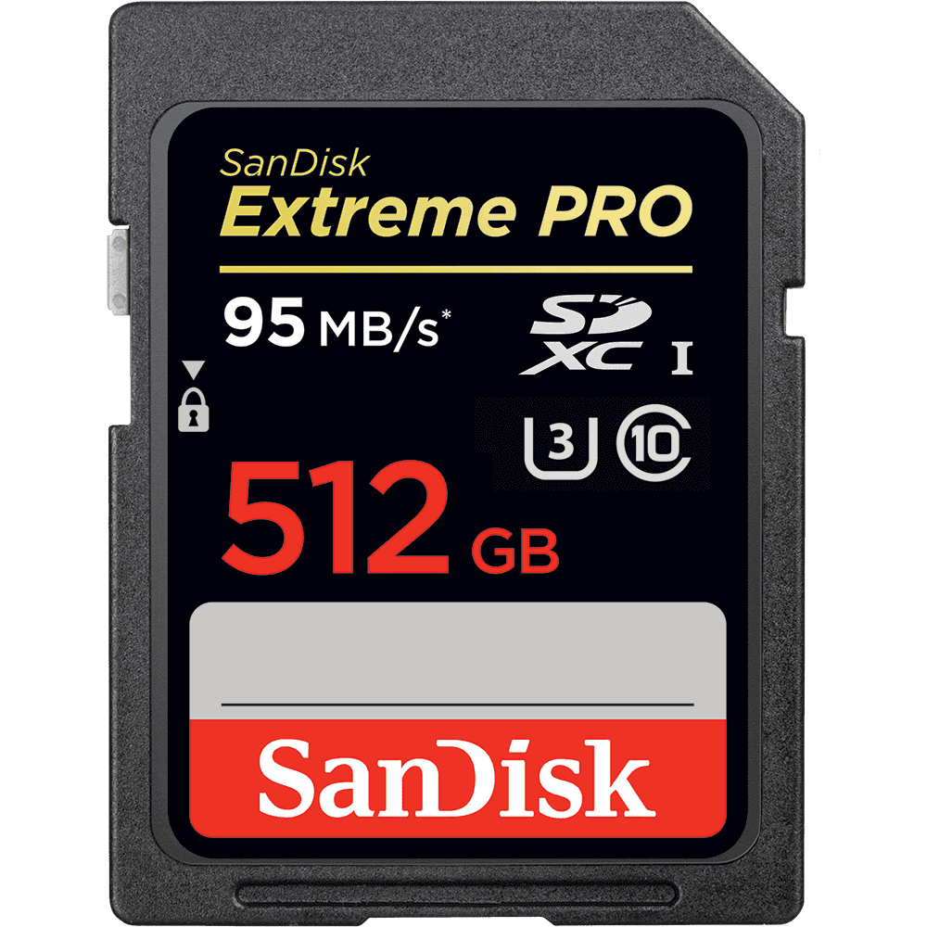

SHOOT WITHOUT LIMITS

Our most powerful and highest capacity SD™ UHS-I memory card delivers maximum speed for performance, reliability, and uncompromising image and 4K UHD video[1](https://www.sandisk.com/home/memory-cards/sd-cards/extremepro-sd-uhs-i#footnotes) quality from your DSLR, advanced digital or HD video camera. Transfer speeds up to 95 MB/s[*](https://www.sandisk.com/home/memory-cards/sd-cards/extremepro-sd-uhs-i#footnotes)move your data fast for efficient post-production workflow.

* **Capacity:** 512 GB
* **Read Speed:** up to 95 MB/s[1](https://www.sandisk.com/home/memory-cards/sd-cards/extremepro-sd-uhs-i#footnotes)
* **Write Speed:** up to 90 MB/s[1](https://www.sandisk.com/home/memory-cards/sd-cards/extremepro-sd-uhs-i#footnotes)
* **Video Speed:** C10, U3
* **Form Factor:** SDXC